AM000-Asia-China-Mirror-Liaoning-Mongolian-Serpentine Jade-2 Phoenixes-Cloud Motif-Jade-14th c

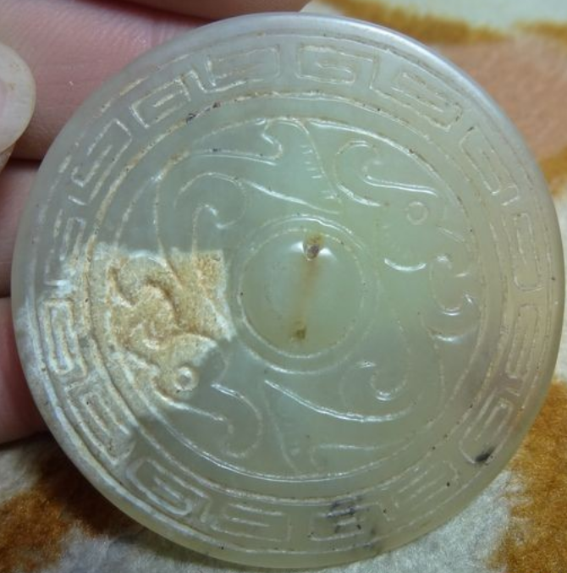

China-Mirror-Liaoning-Mongolian-Serpentine Jade-2 Phoenixes-Cloud Motif-Jade-14th c

Case no.: Mirrors

Accession Number:

Formal Label: China-Mirror-Liaoning-Mongolian-Serpentine Jade-2 Phoenixes-Cloud Motif-Jade-14th c

**Display Description:**

Mongolian Shaman’s Phoenix Mirror of Heavenly Ascent, Liaoning Province, Serpentine Jade, 2 Phoenixes within a stylized cloud motif symbolizing eternity, ca. 14th century.

Liaoning遼寧 is a northeast province of the People's Republic of China, named for the Liao River that flows through the province and "Níng" which means "peace." This mirror carved from a serpentine jade is of Mongolian manufacture based on its iconography and may have been produced by the Mongolian peoples who controlled the Liaoning area prior to the period when the Ming Empire took control of Liaoning in 1371, just three years after the expulsion of the Mongols from Beijing. It may have been attached to a Mongolian's shaman’s cape that was usually adorned with mirrors to reflect his ascent to the upper-world of the spirits.

The obverse of a Chinese Mirror has a metaphoric didactic morality or partisanship as its foundational imagery. For instance, a mirror could evoke the heavens through cloud imagery and heavens could then be connected to the infinitude of time or the mandate given rulers to govern by. In this latter sense heavenly imagery could refer to the ruler himself.

For instance, in Tang China (618–907 CE) under the second Tang Emperor Li Shimin, known as Tang Taizong (626–649), professional historians were appointed by the Emperor, and they formed a commission that politically appropriated historical interpretation. This commission termed Tang Taizong’s reign, which lasted for only 23 years from 627 to 649, as 真 關,“True Vision,” even though Taizong, killed the crown prince, forced his father to abdicate and consolidated his rule in 630 with a victory over the Mongolians in the north and the west.

Then, on the reverse side, the mirror’s ability to capture light from its heavenly source was the aspect that captured its magical properties. The reflection of the self thus became a reflection superimposed on this supreme source and therefore reflected one’s morality by the infinitude of light’s heavenly source like an Eastern Orthodox or Russian ikon.

Similarly, for a shaman to be dressed in his robes with glittering mirrors affixed to it was to amplify this reflection of the infinite.

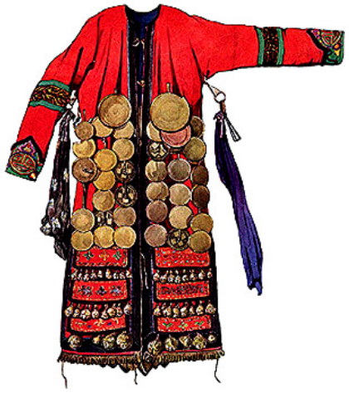 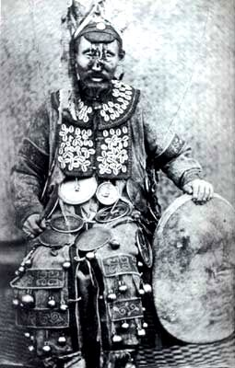 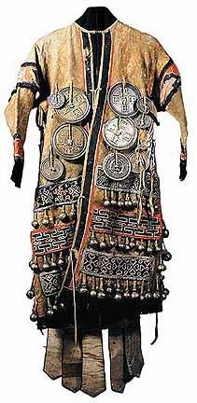

Figs. Mongolian shamans’ cloaks with mirrors attached. After [http://i589.photobucket.com/albums/ss334/Buddha-love/SPIRITUAL%20SKY%20Pics%20for%20eBay/Shaman-Coat-1\_zpsjcmksqw8.jpg](http://i589.photobucket.com/albums/ss334/Buddha-love/SPIRITUAL SKY Pics for eBay/Shaman-Coat-1_zpsjcmksqw8.jpg)

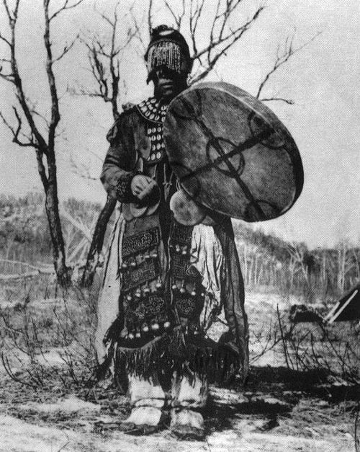 

Fig. 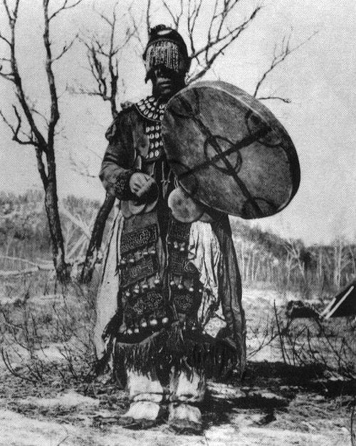

Therefore, this Liaoning jade mirror is an adaptation from the metallic Mongolian model as its jade counterpart. Shaman's cloaks were an essential part of ancient traditions. They were made from a combination of silk and fur and affixed to them, in addition to bronze mirrors (Toli and Melong), were glass beads, shells, bronze bells, pieces of blessed and empowered cloth, thogchags (Mongolian & Tibetan charms). Therefore, these cloaks can be very heavy because of these objects in which inheres the spiritual and psychological power that the Shaman employs in healing and magical work. By wearing cloaks such as these the Shaman is actually wearing his magical universe in the same way that tattoos are worn on the body. This cloak is also an apotropaic protective covering of heavenly light captured by the mirrors, his own sacred spirits that protects him from dark and dangerous forces while he heals.

Formal Label: Mongolian Shaman’s Phoenix Mirror of Heavenly Ascent, Liaoning Province, Serpentine Jade, ca. before the Ming Empire took control of Liaoning in 1371. Size: 50mm. dia. x 5 mm. thickness.

Accession Number: DS752/NK8440

Date or Time Horizon: ca. 14th century. Size: 50mm. dia. x 5 mm. thickness.

Geographical Area: Liaoning Province, Mongolia

Map:

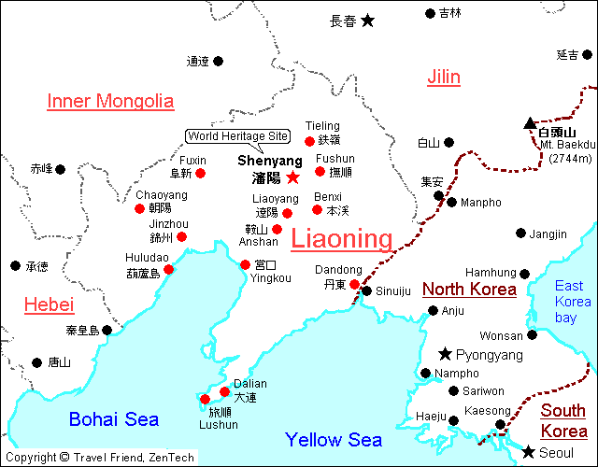

GPS:

Cultural Affiliation: Mongolian

Medium: Serpentine Jade

Dimensions: Dia. 50 mm. dia. x Thickness 5 mm.

Weight:

Provenance: Originally this was affixed to a Mongolian shaman’s cape.

**Condition: Museum grade**

**Discussion:** This mirror is carved from serpentine jade from **Liaoning** 遼寧 , “Laio River made peaceful,” named for the Liao River that flows through this northeast province of the People's Republic of China. Based on its iconography, it is of Mongolian manufacture and was carved before the Ming Empire took control of Liaoning in 1371, just three years after the expulsion of the Mongols from Beijing. (Dardess 2012: 18). This mirror was probably attached to a Mongolian's shaman’s cape traditionally adorned with many mirrors to literally “reflect” the shaman’s heavenly ascent to the upper-world of the spirits, and, with this mirror, the shaman was helped by the two carved Phoenixes that “f ly” within a stylized cloud motif symbolizing eternity.

Mongolian shamanism, Tengerism or Böö mörgöl (Бөө мөргөл), is devoted to the worship of the *tngri* (gods) and the highest *Tenger* or *Qormusta Tengri,* is Heaven(Balzer 2000). Generally, 99 *tngri* are worshipped, butsome liturgical texts add another 33 that are invoked only by the highest shamans for special occasions. Chief among the *tngri* are Qormusata Tngri and (Khan) Möngke Tngri, the latter named after Yesükhei (d. 1171)the father of Genghis Khan (1162 – August 18, 1227) and the main embodiment of the *Tenger*. One sect has been syncretized with Buddhism and is known as Yellow Shamanism, since its members wear yellow hats during services, while the sect not influenced by Buddhism is called Black Shamanism.

**References:**

Balzer, Marjorie Mandelstam. 2010. Religion and Politics in Russia: A Reader. Armonk, N.Y.: M.E. Sharpe.

Dardess. John W. 2012. Ming China, 1368-1644: A Concise History of a Resilient Empire. New York: Rowman and Littlefield.

Walther Heissig. *The Religions of Mongolia*. London: Routledge, 2000.

Dimensions: 50mm. dia. x 5 mm. thickness

Weight:

Condition:

Provenance:

**Discussion:**

**References:**

Mongolian Mirror, Liaoning Province, Serpentine Jade, 2 Phoenixes within a stylized cloud motif symbolizing eternity, ca. 14th century.

Size: 50mm. dia. x 5 mm. thickness.

**Liaoning** 遼寧 is a northeast province of the People's Republic of China, named for the Liao River that flows through the province and "Níng" which means "peace." This mirror carved from a serpentine jade is of Mongolian manufacture based on its iconography and may have been produced by the Mongolian peoples who controlled the Liaoning area prior to the period when the Ming Empire took control of Liaoning in 1371, just three years after the expulsion of the Mongols from Beijing. It may have been attached to a Mongolian's shamans cape that was usually adorned with mirrors to reflect his ascent to the upper-world of the spirits.